**ECE374 Assignment 7**

Due 04/03/2023

**Group & netid**

*Chen Si chensi3*

*Jie Wang jiew5*

*Shitian Yang sy39*

**Problem 3**

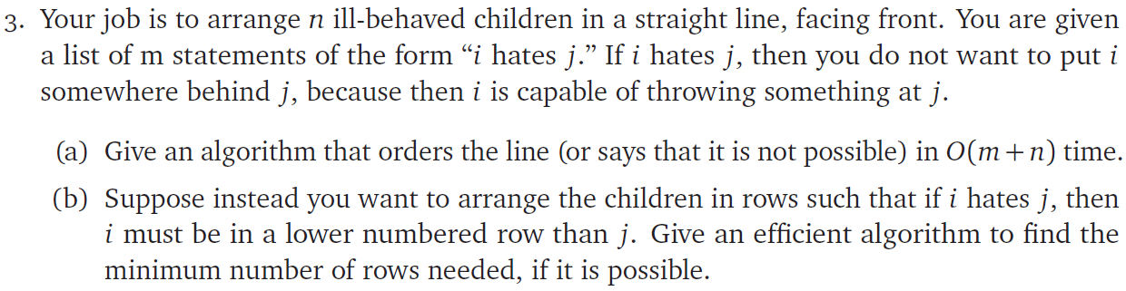

(a) Solution:

Intuition: We could transform this problem as a graph, where each child is a node in the graph, and we mark the hate relationships like “i hates j” as an edge that point from i to j. Then, with performing a topological sort of the graph from left to right, we could ensure that for each hate relationship “i hates j”, we would sort the node i ahead of node j in the topologically sorted sequence, and therefore meets the requirement of the question.

If the graph that we constructed could be topologically sorted (it’s a DAG), we could have an order of the line successfully. Otherwise we may not have such an ordered line.

Therefore, the algorithm is:

**GetOrder**(n, Hates[1,…,m]):

// Initialize graph

G = Graph()

for i 🡨 1 to n:

G.addVertex(i) // Add vertices

for k 🡨 1 to m:

(i, j) = Hates[k] // “i hates j”

G.addEdge(i, j) // Add edge from i to j

if isCyclic(G): // Check if we could topological sort

return False // Can’t arrange

sorted = TopSort(G) // Get topological sort results

return sorted

isCyclic is a helper function that checks if a graph has cycles with DFS (run time O(m+n)):

**DFS**(G, u, visited, parent) {

visited[u] = True

for each v ∈ G.Adj[u]

if visited[v] == False

if DFS(G, v, visited, u) == True

return True

else if v != parent

return True

return False

}

**isCyclic**(G(V,E)) {

visited = [false]*V

for each u ∈ G

if visited[u] == False

if DFS(G, u, visited, -1) == True

return True

return False

}

Topological Sort Algorithm cited from lecture 16:

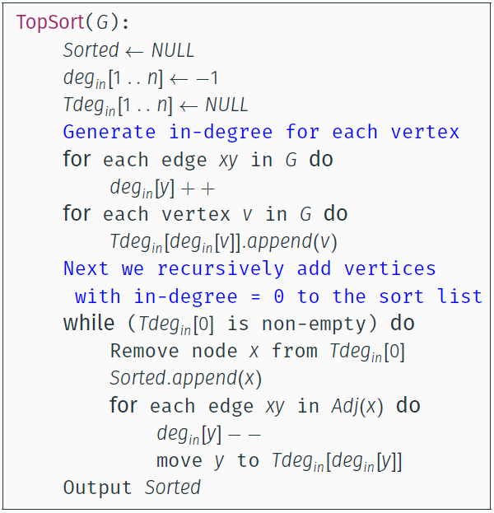

Run Time Analysis:

(1) Initialize empty graph: O(1)

Insert n nodes (n child): O(n)

Insert m edges (m hates relationships): O(m)

(2) Check cycle with DFS: O(m+n)

(2) Topological Sort: O(m+n)

Therefore, the runtime of this algorithm is O(m+n).

(b) Solution:

Intuition: We could modify the code in (a) to transform the order to the form of sitting in rows.

Base Case: For each node, if it doesn’t have a “parent node”, meaning that there’s no incoming edge, it could be placed at the first row – (row number = 1).

General Case: For each node, we could obtain a list of its “parent node”, the row number of the current node should be 1 + the max row number of its parents, as this child must be placed at least one row after the last one it would bully.

Therefore, it’s turned into a dynamic programming problem and the following algorithm is purposed. We could use a n length table to store the row values, and the minimum number of rows is the maximum value stored in the table after iterating through all nodes.

**GetNRows**(n, Hates[1,…,m]):

G = Graph()

parent_dict = {} // Dictionary of Lists

for i 🡨 1 to n:

G.addVertex(i) // Add vertices

for k 🡨 1 to m:

(i, j) = Hates[k] // “i hates j”

G.addEdge(i, j) // Add edge from i to j

parent_dict[j].add(i) // mark j as one of i's parents

if isCyclic(G):

return False // Can’t arrange

sorted = TopSort(G) // Get topological sort results

T = Table(1,n) // Initialize a 1×n table to store the values

for i 🡨 1 to n:

parents = parent_dict[sorted[i]]

if len(parents) == 0:

T[i] = 1 // If no parents occur, sit in row 1

else:

T[i] = 1 + max(T[p] for p in parents)

return max(T)

This algorithm has a run time of O(m+n), as the topological sorting part from (a) is O(m+n), and the for loop for dynamic programming has n loops with nearly constant time for each loop. We have the total time cost to be O(m+n).